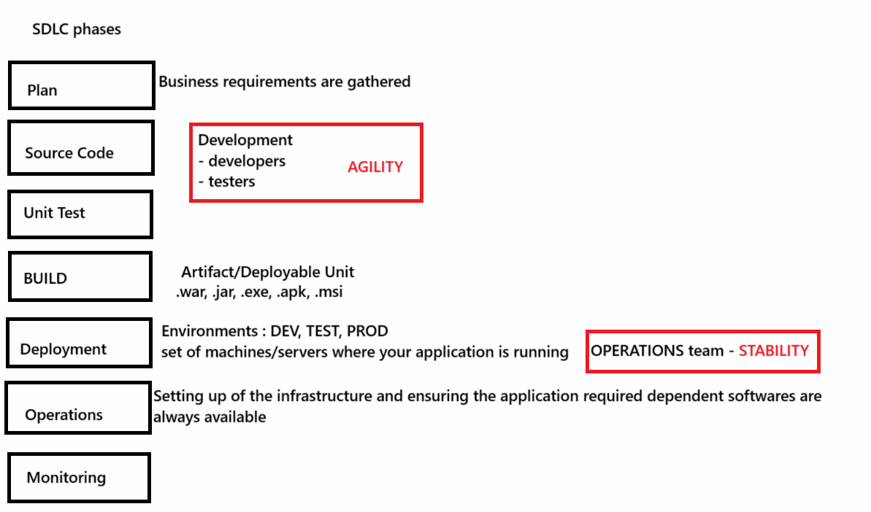

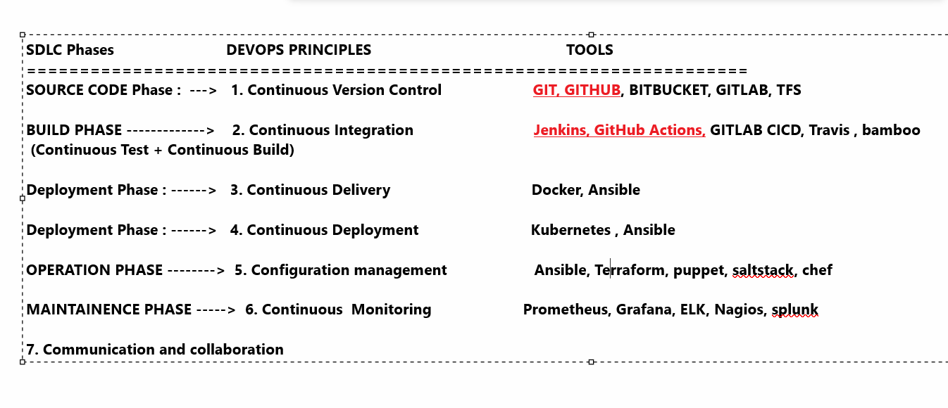

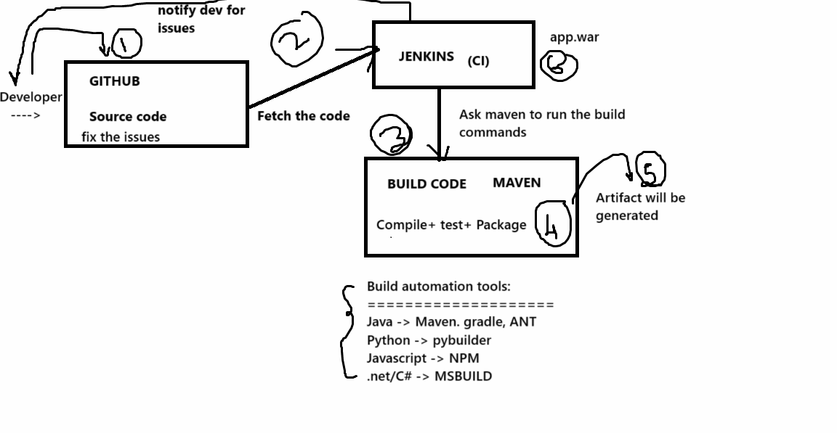

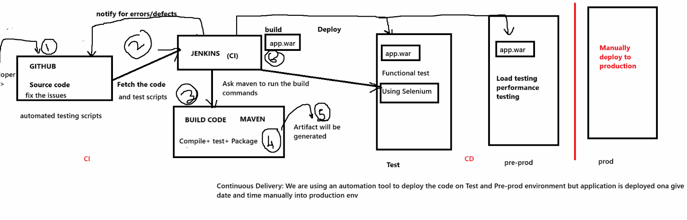

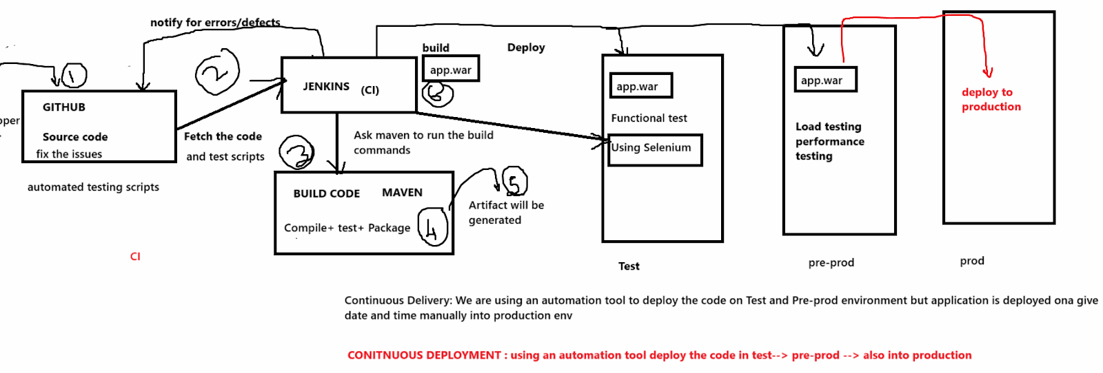

Clone in GIT:
=======================
Go to the terminal

# sudo su -

# git clone
https://github.com/jnareshkumar/DevOps_Project_April2025.git

https://github.com/Sonal0409/myproject26sept-sonal.git

It will create a working directory with name as DevOps_Project_April2025

It will create a git repo

# cd DevOps_Project_April2025
# ls -al

# git log --oneline

# git remote -v

==================================================

CONTINUOUS INTEGRATION:
===================================================

With Devops we have to automate the entire process of Build
This can be achieved by using an automation tool that will manage integration with
- Version control tool - to fetch the code
- Build tool - to compile, review, test and package the code
Various build tool : Maven, Ant , gradle, MSbuild, pybuilder

The integration/automation tool is Jenkins
We have many integration tools like:
Jenkins
Gitlab CICD
travis
bamboo
teamcity
Github actions
Airflow

The integration service on various cloud platforms:
AWS- code pipeline
Azure-Azure pipelines
GCP - Code build
Digital ocean - pipelines

Jenkins:
===============
It is an automation tool that integrates with various tools to provide an automated SDLC pipeline
Jenkins can automate entire build and automation process
It is an automation server, Jenkins support building, deploying and automating any project.
Pls note:
jenkins is not a build tool
jenkins is not a testing tool
jenkins is not a deployment tool
jenkins is not a monitoring tool

Jenkins features:
==================
> Open source tool, free
> Enterprise version of Jenkins can also be used which is provided by cloudbees.
> Jenkins is a java based tool
> for us to install and work with Jenkins we have to first install java(JDK) version 17 OR 21
> Jenkins can be installed on windows, Mac or linux OS
> Jenkins is a plugin based tool
plugin - an extension, a small tool that enhances the capability of the main tool
> Jenkins has 100s of plugins to support integration process with various tools
For example: If we want Jenkins to send notification to our slack channel than we download
slack notification plugin on jenkins that will help to configure jenkisn+slack integration
> CICD pipelines : In Jenkins we make use of declarative pipeline syntax to write pipeline code
Pipeline -> a set of tasks which are executed one after the other in a sequence
To create the pipeline - we have to write pipeline code
It is written in declarative pipeline syntax - which is based on groovy scripting
> Secure tool -> security features -> Matrix based security or project based security
> We can create users and give them role based access to them
> We can setup a high availability server and can ensure regular backup of Jenkins server
> Jenkins Controller -> main VM where we have all the pipelines created but they are not exeucted on this VM
Rather the controller is connect to agents where the piplines and tasks are executed.
This setup is called master and Agent setup in jenkins.

We will work on the jenkins dashboard instead of the terminal.

Setup jenkins on the Lab
====================

Go to browser:
Give URL as : localhost:8080

Username: admin
Password: InitialAdminPassword

You will be on jenkins dashboard
For the setup to be complete, we have to update the jenkins plugins
Go to manage jenkins → Scroll down to Plugins
Click on updates:

Select the checkbox for updates and click on update button

Give few mins for updates to complete

Now reset jenkins

Scroll down and click on checkbox to restart jenkins server

===============================================
Hardware req for jenkins:
4GB RAM and 2CPU core

Steps to Install jenkins on UbuntuOS:
========================================================================

https://www.jenkins.io/doc/book/installing/linux/#debianubuntu

\
Steps to Install jenkins on Amzon Linux or RHEL OS:
========================================================================

https://www.jenkins.io/doc/book/installing/linux/#red-hat-centos

Install jenkins on Windows:
=========================
https://www.jenkins.io/doc/book/installing/windows/

Steps to Install jenkins on Ubuntu 22

Install java version 17

# sudo apt update

# sudo apt install openjdk-17-jdk -y

Install jenkins on Ubuntu 22:

sudo wget -O /usr/share/keyrings/jenkins-keyring.asc https://pkg.jenkins.io/debian-stable/jenkins.io-2023.key
echo "deb [signed-by=/usr/share/keyrings/jenkins-keyring.asc]" https://pkg.jenkins.io/debian-stable binary/ | sudo tee /etc/apt/sources.list.d/jenkins.list > /dev/null
sudo apt-get update
sudo apt-get install jenkins
systemctl start jenkins

Demo 1: Create a JENKINS job that will execute linux commands.
=========================================

Create a new job in jenkins
Click on + sign to create new item/job/project
Give a name to the job : Job1
Select freestyle project and click on OK button
Go to build Steps→ select Execute Shell→ give commands like
touch file1
echo “hello Jenkins!”

Save the job → click on build Now button.

See the console output and check the workspace directory.

Jenkins Integration with Git and Github-> Source code management tool
============================================

Demo 2: Create a Jenkisn job that will clone a github repository in jenkins workspace

Create a new job in jenkins
Click on + sign to create new item/job/project

Give a name to the job : CloneRepo
Select freestyle project and click on OK button

On the project click on Source code management
Select git option

Give git hub repo path
https://github.com/Sonal0409/myproject-03Feb-Sonal.git

Branch name as ===> Master

Save the job

Click on Build now

Click on workspace

Repository will be cloned in jenkins workspace

=========================================

Demo: Maven Integration with jenkins
=============================

Jenkins--> Manage Jenkins-->Tools

Under GIT==> leave it same

Under maven ==> lets install it automatically

Type:
Name as : mymaven and
check the install automatically box.
Save the changes

We can check maven installation in the following location

# cat /var/lib/jenkins/hudson.tasks.Maven.xml

When jenkins installs a tool its scope is only /var/lib/jenkins directory -> JENKINS_HOME

========================================================

Package Job
***************************

Go to jenkins--> new item--> Name= Package==> freestyle project
==> source codemanagement==>select git==> give git repo

https://github.com/Sonal0409/DevOpsCodeDemo.git

build ==> invoke top level maven target==>mymaven

goal = package

==> save==> build now
==> click on build number and see the console

==> go to workspace ==> target/addressbook.war

=========================================
Jenkins Continous integration Pipeline

===========================================

Create a new job → Integration-piepline-> select pipeline template

Add below code in pipeline section

pipeline{

agent any

tools{
maven 'mymaven'
}

stages{

stage('Checkout code '){
steps{

git 'https://github.com/Sonal0409/DevOpsCodeDemo.git'

}
}

stage('compile code '){
steps{

sh 'mvn compile'

}
}

stage('Test code '){
steps{
sh 'mvn test'
}
}

stage('Package code '){
steps{

sh 'mvn package'

}
}

}
}

Save the job→ build Job → click on stages

